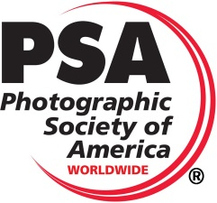
The 2020 Detroit International Stereo Exhibition
The
Detroit Stereographic Society

Exhibition Co-Chairs
Barbara Gauche | Dennis Green
46576 Vineyards Lane | 550 E. Webster
Macomb, MI 48042 | Ferndale, MI 48220
bpgauche@msn.com | dennisgreen@comcast.net
PSA 2020-463
PSA 3D Division

Panel of Judges for All 3 Sections  David Dorney, Ann Arbor, Michigan, Judge and International Stereo Exhibitor  Paul Gauche, Macomb Township, Michigan, Judge and International Stereo Exhibitor  Fred Huntzicker, Ann Arbor, Michigan, Judge and International Stereo Exhibitor |  | Calendar  Closing Date Monday, November 16, 2020  Judging – Livonia, Michigan Saturday, November 21, 2020  Results and Digital Exhibition  Posted on the Internet Saturday, December 5, 2020  Report Cards E-mailed Saturday, December 5, 2020  Awards Mailed by…………………………….….Friday, February 5, 2021  catalogs posted on the website by..................Friday, February 5, 2021  Exhibition Dates  Cleveland, Ohio Tuesday, January 5, 2021  Livonia, Michigan Wednesday, January 13, 2021
Entry forms may be obtained through the Exhibition Page on the DSS Website: www.Detroit3D.org
 | Awards
Stereo Digital Section –  “Open” | Stereo Digital Section –  “Creative” |  | Stereo Digital Section –  “People at Work”
Best of Show (PSA 3D Division Gold Medal) | Best of Show (PSA 3D Division Gold Medal) |  | Best of Show (PSA 3D Division Gold Medal)
Best “Animal” | Best “Through the Stereo Window” |  | Best “Use of 3D”
Best “Fishing” (Helin Tackle Award)
3 Judges Choices | 3 Judges Choices |  | 3 Judges Choices
Honorable Mention  (10% of the balance of accepted slide images ) | Honorable Mention  (10% of the balance of accepted section images ) |  | Honorable Mention  (10% of the balance of accepted section images )

All Award Winners, HMs and Acceptances will be posted on the Internet at the following Web Site: www.Detroit3D.org click on “Exhibition Results”

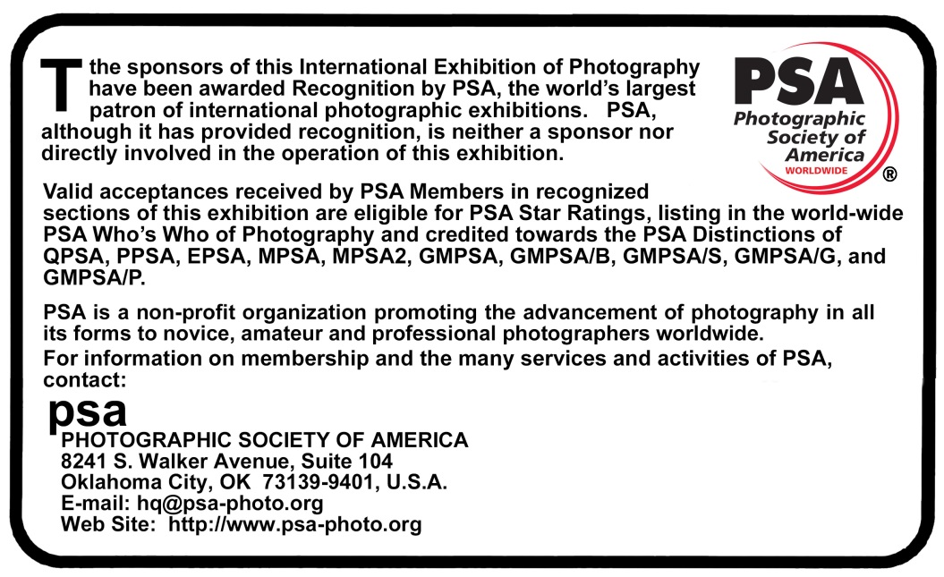
This Exhibition will be conducted according to the practices recommended by PSA

General Information
PSA Requirement: The exhibition is open to anyone; however, an entry may be rejected when the sponsoring organization or its agent, in its reasonable discretion, believes the entry does not conform to the exhibition rules and conditions.
An entrant’s images will not be presented to the judges consecutively. An entrant’s four images will be distributed throughout four rounds of judging in that section. Distribution of images shall be in the same round order as submitted by the entrant.
Entries must originate as photographs (image-captures of objects via light sensitivity) made by the entrant on photographic emulsion or acquired digitally. By virtue of submitting an entry, the entrant certifies the work as his own (aliases are not permitted). The entrant permits the sponsors to reproduce all or part of the entered material free of charge for publication and/or display in media related to the exhibition. This may include low resolution posting on a website. Note: Entrants who indicate that their images may not be reproduced or used “will not be eligible for awards” or inclusion in audio-visuals of the exhibition “and could be subject to disqualification” by the exhibition sponsors.
The exhibition assumes no liability of any misuse of copyright. Images may be altered, either electronically or otherwise, by the maker. Artwork or computer graphics created by the entrant may be incorporated provided the photographic content predominates, subject to Nature, Photo Travel and Photojournalism divisional restrictions. All final work must be on photographic film, or on electronic file, or on photographic or electronic print material, mounting excepted.
No title or identification of the maker shall be visible anywhere on the face of an image, print mat or mount entered in a PSA Recognized exhibition.
Each image must have a unique title. Once an image has been accepted in a PSA Recognized exhibition, that same image, or a like “in camera” or a “reproduction” duplicate of that image:
  - May not be entered or re-entered in any section of the same Division Star Ratings class in that exhibition regardless of media, format, or title.
  - May not be re-titled for entry in any other PSA Recognized exhibition, including translation into another language.
  - Images meeting the Monochrome Definition and non-manipulated color images from the same capture shall be considered the same image and must be given the same title.
  - PSA members working on Galaxy and Diamond Star Ratings shall be allowed to continue using different titles of monochrome versions and color versions of the same capture that have already been accepted until the required number of acceptances for those titles have been completed.
Words such as “Untitled” and “No Title” are not acceptable as part or all of an image’s title, nor are camera capture filenames.
An image may be entered in only one section where acceptances of that image in multiple sections would be eligible for the same star path.

Conditions of Entry
If at any time, it is determined in the reasonable discretion of the exhibition organizer or the judges before, during, or after the judging of an exhibition that an entrant has submitted entries where one or more images may fail to comply with these Conditions of Entry, including the stated definitions, the exhibition organizers reserve the right to delete the entry from the exhibition and void any or all acceptances or awards in connection with the exhibition. Fees may be forfeited or refunded in these circumstances. The entrant acknowledges that the decision of the exhibition organizers or the judges is final.
In order to ensure that images comply with the Conditions of Entry and definitions, the exhibition organizers may carry out reasonable measures to verify that:
a) the images are the original work of the entrant and
b) the images comply with the rules and definitions as set out in these Conditions of Entry.
These steps include, but are not limited to, questioning any entrant, requiring the submission of RAW files or other digital files representing the original capture of the submitted image(s), confronting the entrant with evidence that one or more submitted images fails to comply with the Conditions of Entry (also known as Entry Rules), and offering the entrant a reasonable opportunity to provide counter evidence to refute the exhibition organizer’s evidence by a set deadline. Such entries that are not cleared or are still questionable after the entrant has presented evidence may be considered in breach of these Conditions of Entry, and declined. Such entries may be referred to PSA for further investigation of possible ethics violations.
PSA retains the right to investigate in any way all complaints/suspicions of breaches of entry conditions, impose sanctions if deemed necessary, void the acceptances of any image found to violate the PSA rules, include the entrant’s name on the list of sanctions provided to Exhibitions, and share such investigations with FIAP. Entrants automatically agree to these terms by the act of entering the Exhibition and agree to cooperate with any investigation.

Data Protection:
By entering this exhibition, you are explicitly consenting to the personal details you have supplied, including email addresses, being held, processed and used by the exhibition organizers for purposes associated with this exhibition. You also explicitly consent to such information being sent to organizations that have accorded official recognition, patronage or accreditation to this exhibition. You acknowledge and accept that entering this exhibition means that the status and results of your entry may be made public.

Notice
When an entrant fills in the Entry Form to submit an entry, the entrant will see a feature to affirm he or she has read these Conditions of Entry when he or she fills out the entry form. If the entrant does not so affirm the entry will not be submitted.

Number of Entries
A maximum of four entries may be submitted for each section. Images (Slides or Digital) previously accepted at a Detroit International Stereo Exhibition*, or so similar as to be almost identical, regardless of title, are ineligible in any format. New work is required. An entrant's four images in a section will be distributed throughout four rounds of judging.

Categories
Attention is drawn to the awards allocated to various categories, and entries are especially sought for all of these.

Acceptances
A maximum of 45% of entries will be accepted.

Entry Fee
The Digital entry fee is $USD6.00 per section worldwide.
Cash or $USD check made payable to “DSS” may be sent for one or all sections.
Checks should be sent to Dennis Green at: 550 E Webster Street, Ferndale, MI 48220
PayPal payments sent to DennisGreen@Comcast.net may be made for one or all sections.

Catalog
A PDF downloadable copy of the catalog will be put on the website and the list of acceptances, awards, etc. will be sent to PSA 3D Directors compiling “Who’s Who in Stereo Photography,” “Star Ratings” and “Image-of-the-Year” records.

E-mailed Report Cards
Report cards will be sent to the “Preferred E-Mail Address for Correspondence” specified in the entry form.

Modification
Any modification of original images must be made by, or under the direction of, the exhibitor.

- Also applies to any images accepted in the Exhibition under its previous titles, the Detroit International Stereo Slide Exhibition and the Detroit International Salon of Photography.
Stereo Digital Image Section Instructions
Each stereo image entry must consist of a single parallel view JPEG file. Maximum file size of each file should not exceed 2MB, total not to exceed 8MB. Maximum image width (horizontal) of each individual image is 1920 pixels and the height (vertical) is 1080 pixels, resulting in a combined file dimension of 3840 by 1080 pixels. We recommend the resize or multi-conversion features of StereoPhoto Maker for resizing from the original image dimensions to the required size.
File Naming: Please name the files containing your images as follows:
Lastname_Firstname_Image Title_n.jpg
Where n=1, 2, 3, and 4 in the order you wish them to be judged.
(Example: Gauche_Paul_Sunset at the Lake_1.jpg)
Please use underscores to separate the segments, and spaces (or hyphens where appropriate) between words in the image title, but no other special characters such as commas, brackets, periods, slashes, etc. If you have any questions regarding this format, please contact the Exhibition Chairman.

Judging Method
Judging will be by projection using a single full HD Optoma HD26 3D projector or by using a single LG UH8500 (UHD 3D TV) in a single session with all judges for each section present, if possible, based on state laws regarding the number of people allowed to meet in a group. If the judges are not able to meet in a group, they will judge the images on their own personal viewing equipment.

Submission
Entries for each section must be sent in separate E-mails.

Attach all four entries to an E-mail and send to: DennisGreen@Comcast.net

Please include “Detroit Exhibition Entries – Section Title” in the subject line. We will try to acknowledge receipt of the E-mail within 48 hours. If you have not received acknowledgement within 48 hours, please contact us again so we can ensure your images are included in the judging. If you have a problem with E-mail reaching the above address, use the following alternate E-mail address: bpgauche@msn.com.

Copy the following and include the completed information in your E-mail:

“I have read the General Information and Conditions of Entry for this Exhibition.”
Name________________________________________________________________
Address______________________________________________________________
City ______________________________ State/Province______________________
Zip/Postal Code___________ Country_____________________________________
Preferred E-Mail Address for Correspondence________________________________
PSA Star Rating_____________________ PSA Honors_______________________

