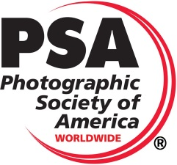
The 2019 Detroit International Stereo Exhibition
The
Detroit Stereographic Society

Exhibition Co-Chairs
Barbara Gauche | Dennis Green
46576 Vineyards Lane | 550 E. Webster
Macomb, MI 48042 | Ferndale, MI 48220
bpgauche@msn.com | dennisgreen@comcast.net
PSA 2019-402
Stereo Slides & Stereo Digital

Panel of Judges  Lindel Salow, Dearborn, Michigan, Judge and International Stereo Exhibitor  Keith Taitt, Grosse Pointe, Michigan, Judge and International Stereo Exhibitor  Mary Taitt, Grosse Pointe, Michigan, Judge and International Stereo Exhibitor |  | Calendar  Closing Monday, September 23, 2019  Judging – Livonia, Michigan Saturday, September 28, 2019  Results and Digital Exhibition  Posted on the Internet Saturday, October 19, 2019  Report Cards E-mailed by Saturday, October 5, 2019  All Slides, Catalogs and Awards  Mailed by Friday, December 13, 2019  Exhibition Dates – Slides and Digital  Richfield, Ohio Tuesday, November, 5, 2019  Livonia, Michigan Wednesday, November 13, 2019
Entry forms may be obtained through the Exhibition Page on the DSS Website: www.Detroit3D.org
 | Awards
Stereo Slide Section – Open | Stereo Digital Section – Open |  | Stereo Digital Section – Architecture
Best of Show (PSA 3D Division Gold Medal) | Best of Show (PSA 3D Division Gold Medal) |  | Best of Show (PSA 3D Division Gold Medal)
Best “Slow Shutter / Long Exposure” | Best “Creative / Illusion” |  | Best “Reflection”
3 Judges Choices | Best “Fishing” (Helin Tackle Award) |  | 3 Judges Choices
 | 3 Judges Choices
Honorable Mention  (10% of the balance of accepted slide images ) | Honorable Mention  (10% of the balance of accepted section images ) |  | Honorable Mention  (10% of the balance of accepted section images )

All Award Winners, HMs and Acceptances will be posted on the Internet at the following Web Site: www.Detroit3D.org click on “Exhibition Results”

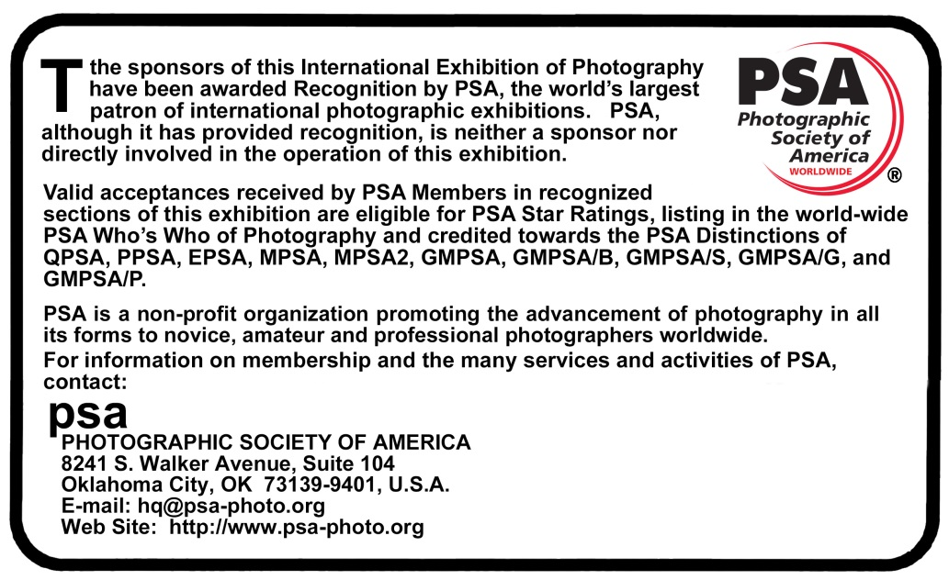

This Exhibition will be conducted according to the practices recommended by PSA

General Information
PSA Requirement: The exhibition is open to anyone; however, an entry may be rejected when the sponsoring organization or its agent, in its reasonable discretion, believes the entry does not conform to the exhibition rules and conditions.
An entrant’s images will not be presented to the judges consecutively. An entrant’s four images will be distributed throughout four rounds of judging in that section. Distribution of images shall be in the same round order as submitted by the entrant.
Entries must originate as photographs (image-captures of objects via light sensitivity) made by the entrant on photographic emulsion or acquired digitally. By virtue of submitting an entry, the entrant certifies the work as his own (aliases are not permitted). The entrant permits the sponsors to reproduce all or part of the entered material free of charge for publication and/or display in media related to the exhibition. This may include low resolution posting on a website. Note: Entrants who indicate that their images may not be reproduced or used “will not be eligible for awards” or inclusion in audio-visuals of the exhibition “and could be subject to disqualification” by the exhibition sponsors.
The exhibition assumes no liability of any misuse of copyright. Images may be altered, either electronically or otherwise, by the maker. Artwork or computer graphics created by the entrant may be incorporated provided the photographic content predominates, subject to Nature, Photo Travel and Photojournalism divisional restrictions. All final work must be on photographic film, or on electronic file, or on photographic or electronic print material, mounting excepted.
No title or identification of the maker shall be visible anywhere on the face of an image, print mat or mount entered in a PSA Recognized exhibition.
Each image must have a unique title. Once an image has been accepted in a PSA Recognized exhibition, that same image, or a like “in camera” or a “reproduction” duplicate of that image:
  - May not be entered or re-entered in any section of the same Division Star Ratings class in that exhibition regardless of media, format, or title.
  - May not be re-titled for entry in any other PSA Recognized exhibition, including translation into another language.
  - Images meeting the Monochrome Definition and non-manipulated color images from the same capture shall be considered the same image and must be given the same title.
Words such as “Untitled” and “No Title” are not acceptable as part or all of an image’s title, nor are camera capture filenames.
An image may be entered in only one section where acceptances of that image in multiple sections would be eligible for the same star path.

Conditions of Entry
If at any time, it is determined in the reasonable discretion of the exhibition organizer or the judges before, during, or after the judging of an exhibition that an entrant has submitted entries where one or more images may fail to comply with these Conditions of Entry, including the stated definitions, the exhibition organizers reserve the right to delete the entry from the exhibition and void any or all acceptances or awards in connection with the exhibition. Fees may be forfeited or refunded in these circumstances. The entrant acknowledges that the decision of the exhibition organizers or the judges is final.
In order to ensure that images comply with the Conditions of Entry and definitions, the exhibition organizers may carry out reasonable measures to verify that:
- the images are the original work of the entrant and
- the images comply with the rules and definitions as set out in these Conditions of Entry.
These steps include, but are not limited to, questioning any entrant, requiring the submission of RAW files or other digital files representing the original capture of the submitted image(s), confronting the entrant with evidence that one or more submitted images fails to comply with the Conditions of Entry (also known as Entry Rules), and offering the entrant a reasonable opportunity to provide counter evidence to refute the exhibition organizer’s evidence by a set deadline. Such entries that are not cleared or are still questionable after the entrant has presented evidence may be considered in breach of these Conditions of Entry, and declined. Such entries may be referred to PSA for further investigation of possible ethics violations.
PSA retains the right to investigate in any way all complaints/suspicions of breaches of entry conditions, impose sanctions if deemed necessary, void the acceptances of any image found to violate the PSA rules, include the entrant’s name on the list of sanctions provided to Exhibitions, and share such investigations with FIAP. Entrants automatically agree to these terms by the act of entering the Exhibition and agree to cooperate with any investigation.

Notice
When an entrant fills in the Entry Form to submit an entry, the entrant will see a feature to affirm he or she has read these Conditions of Entry when he or she fills out the entry form. If the entrant does not so affirm the entry will not be submitted.

Date Protection
By entering this exhibition, you are explicitly consenting to the personal details you have supplied, including email addresses, being held, processed and used by the exhibition organizers for purposes associated with this exhibition. You also explicitly consent to such information being sent to organizations that have accorded official recognition, patronage or accreditation to this exhibition. You acknowledge and accept that entering this exhibition means that the status and results of your entry may be made public.

Number of Entries
A maximum of four entries may be submitted for each section. Images (Slides or Digital) previously accepted at a Detroit International Stereo Exhibition*, or so similar as to be almost identical, regardless of title, are ineligible in any format. New work is required. An entrant's four images in a section will be distributed throughout four rounds of judging.

Categories
Attention is drawn to the awards allocated to various categories, and entries are especially sought for all of these.

Target Range for Acceptances
25% - 45% of entries will be accepted.

Entry Fee
The Digital entry fee is USD$6.00 per section worldwide.
The Slide entry fee is USD$8.00 US & Canada, USD$12.00 overseas.
Cash or USD$ check made payable to “DSS” may be sent for one or all sections. PayPal payments sent to DennisGreen@Comcast.net may be made for one or all sections.

Catalog
A PDF downloadable copy of the catalog will be put on the website and the list of acceptances, awards, etc. will be sent to PSA 3D Directors compiling “Who’s Who in Stereo Photography,” “Star Ratings” and “Image-of-the-Year” records.

E-mailed Report Cards
Report cards will be sent via E-mail if an E-mail address is given on the entry form.

Postal Mailed Report Cards
If no E-mail address is given, report cards will be mailed.

Modification
Any modification of original images must be made by, or under the direction of, the exhibitor.

- Also applies to any images accepted in the Exhibition under its previous titles, the Detroit International Stereo Slide Exhibition and the Detroit International Salon of Photography.
Stereo Slide Section Instructions  Slides should be mounted in standard 1-5/8” x 4” (41 x 101mm) mounts only. Non-glassed RBT mounts are preferred; however slides in glass or cardboard mounts will be accepted. Maximum thickness of slides is 1/8”. Slide formats up to and including 8 perf will be accepted. However, due to limitations of the projection equipment, images wider than 30mm may lose some image width during judging. Careful attention to good mounting practice is requested including acceptable placement of the position of the stereo window. Please clean slides before packing.  2” x 2” (50 x 50mm) slides are not permitted.  Loss or Damage: All care will be exercised to guard against loss or damage to slides, but neither the Detroit Stereographic Society, nor any of its officers, can be held responsible in the event of loss or damage in transit or during judging and Exhibition sessions.  Slide Markings: Each slide must be labeled with the title of the slide and the maker’s name and address. The title must be affixed right side up on the front of the slide and a thumb spot affixed to the lower left hand corner as viewed in a hand viewer. Preferably, put name and address on back.  Slide Credit: Credit will be given in the catalog to the makers of all accepted slides. At the public showings, slides will be presented in the form of an audio-visual presentation and the names, cities, states and/or countries of residence of the makers of all accepted slides will be announced.  Judging will be by projection in a single session with all judges for each section present.  Submission: Mail your entries along with a completed entry form (below) to:  Barbara Gauche  46576 Vineyards Lane  Macomb, MI 48042 USA  Return: Overseas entries will be returned by AIR. | Stereo Digital Image Section Instructions  Each stereo image entry must consist of a single parallel view JPEG file. Maximum file size of each file should not exceed 2MB, total not to exceed 8MB. Maximum image width (horizontal) of each individual image is 1920 pixels and the height (vertical) is 1080 pixels, resulting in a combined file dimension of 3840 by 1080 pixels. We recommend the resize or multi-conversion features of StereoPhoto Maker for resizing from the original image dimensions to the required size.  File Naming: Please name the files containing your images as follows:  Lastname_Firstname_Image Title_n.jpg  Where n=1, 2, 3, and 4 in the order you wish them to be judged.  (Example: Gauche_Paul_Sunset at the Lake_1.jpg)  Please use underscores to separate the segments, and spaces (or hyphens where appropriate) between words in the image title, but no other special characters such as commas, brackets, periods, slashes, etc. If you have any questions regarding this format, please contact the Exhibition Chairman.  Judging will be by projection using a single full HD Optoma HD26 3D projector or by using a single LG UH8500 (UHD 3D TV) in a single session with all judges for each section present.  Submission: Attach all four entries to an E-mail and send to:  DennisGreen@Comcast.net  Please include “Detroit Exhibition Entries” in the subject line. We will try to acknowledge receipt of the E-mail within 48 hours. If you have not received acknowledgement within 48 hours, please contact us again so we can ensure your images are included in the judging. If you have a problem with E-mail reaching the above address, use the following alternate E-mail address: bpgauche@msn.com.  Copy the following and include the completed information in your E-mail:  “I have read the General Information and Conditions of Entry for this Exhibition.”  Name__________________________________________  Address________________________________________  City & State/Province______________________________  Zip/Postal Code______ Country_________________  PSA Star Rating___________ PSA Honors___________

Please Complete Entry Form for Stereo Slides
and mail with your slide entries

Please print or type For Committee Use ______________

I have read the General Information and Conditions of Entry for this Exhibition

Last Name |  |  |  |  | First Name
Address
City
State |  |  |  | Zip/Postal Code |  |  |  |  |  | Country
PSA Star Rating |  |  |  |  |  | PSA Honors
E-Mail Address

FEE: The Slide entry fee is USD$8.00 US & Canada, USD$12.00 overseas.
Please make checks (US funds) payable to “DSS”.
Entry fee may be sent via PayPal to DennisGreen@Comcast.net

 | Stereo Slide Titles (Entrant to fill out) | Score | Acc. | Award
1
2
3
4

Address Label  For your use  Return labels will be computer generated from the entry form | Stereo Slides from:  _________________________  _________________________ _________________________  _________________________ |  | To:  Detroit International Stereo Exhibition  Barbara Gauche  46576 Vineyards Lane  Macomb, MI 48042  USA

