**The 2018 Detroit International Stereo Exhibition**

The

Detroit Stereographic Society

|  |  |
| --- | --- |
| **Exhibition Co-Chairs** | |
| Barbara Gauche | Dennis Green |
| 46576 Vineyards Lane | 550 E. Webster |
| Macomb, MI 48042 | Ferndale, MI 48220 |
| bpgauche@msn.com | dennisgreen@comcast.net |

PSA 2018-385

**Stereo Slides & Stereo Digital**

|  |  |  |  |  |
| --- | --- | --- | --- | --- |
| **Panel of Judges**  **Jerry Chisnell**, Judge and International Stereo Exhibitor  **Larry Low**, Judge and International Stereo Exhibitor  **David Smith,** Judge and International Stereo Exhibitor  **Mary Taitt**, Judge and International Stereo Exhibitor  **Keith Taitt**, Judge and International Stereo Exhibitor | | **Calendar**  Closing Monday, September 17, 2018  Judging – Livonia, Michigan Saturday, September 22, 2018  Results and Digital Exhibition  Posted on the Internet Saturday, October 13, 2018  Report Cards E-mailed by Saturday, October 6, 2018  All Slides, Catalogs and Awards  Mailed by Friday, December 7, 2018  Exhibition Dates – Slides and Digital  Richfield, Ohio Tuesday, October 2, 2018  Livonia, Michigan Wednesday, October 10, 2018 | | |
| **Entry forms may be obtained through the Exhibition Page on the DSS Website: www.Detroit3D.org** | | | | |
|  | **Awards** | |  |
| **Stereo Slide Section – Open** | **Stereo Digital Section – Open** | | **Stereo Digital Section – Transportation** |
| Best of Show (PSA 3D Division Gold Medal) | Best of Show (PSA 3D Division Gold Medal) | | Best of Show (PSA 3D Division Gold Medal) |
| Best “Through the Stereo Window” | Best “Creative / Illusion” | | Best “Vintage” |
| 3 Judges Choices | Best “People” | | 3 Judges Choices |
|  | Best “Fishing With Bait”  (Helin Tackle Award) | |  |
|  | 3 Judges Choices | |  |
| Honorable Mention  (10% of the balance of accepted slide images ) | Honorable Mention  (10% of the balance of accepted section images ) | | Honorable Mention  (10% of the balance of accepted section images ) |

All Award Winners, HMs and Acceptances will be posted on the Internet at the following Web Site: [www.Detroit3D.org](http://www.Detroit3D.org) click on “Exhibition Results”

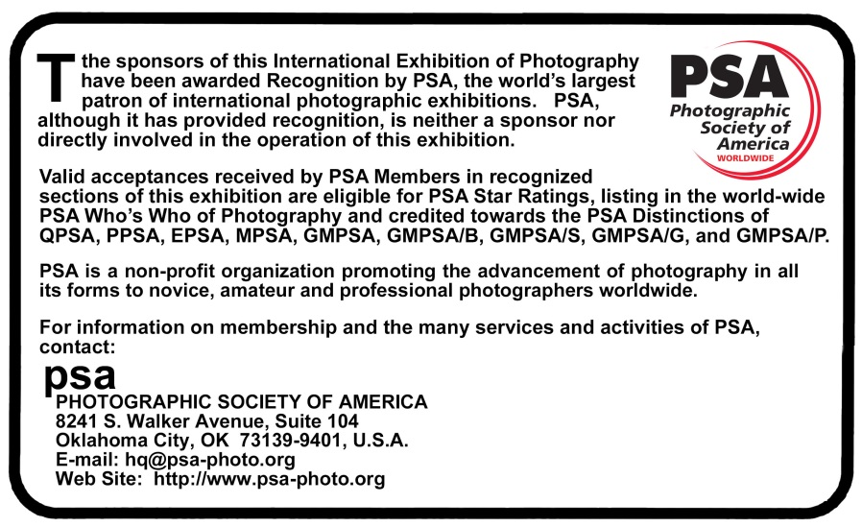

**Conditions of Entry**

This Exhibition will be conducted according to the practices recommended by PSA

|  |
| --- |
| ***General Information***  **PSA Requirement:** The exhibition is open to anyone; however, an entry may be rejected when the sponsoring organization or its agent, in its reasonable discretion, believes the entry does not conform to the exhibition rules and conditions. An entrant’s images will not be presented to the judges consecutively. An entrant’s four images will be distributed throughout four rounds of judging in that section. Distribution of images shall be in the same round order as submitted by the entrant. Entries must originate as photographs (image-captures of objects via light sensitivity) made by the entrant on photographic emulsion or acquired digitally. By virtue of submitting an entry, the entrant certifies the work as his own (aliases are not permitted). The entrant permits the sponsors to reproduce all or part of the entered material free of charge for publication and/or display in media related to the exhibition. This may include low resolution posting on a website. Note: Entrants who indicate that their images may not be reproduced or used “will not be eligible for awards” or inclusion in audio-visuals of the exhibition “and could be subject to disqualification” by the exhibition sponsors. The exhibition assumes no liability of any misuse of copyright. Images may be altered, either electronically or otherwise, by the maker. Artwork or computer graphics created by the entrant may be incorporated provided the photographic content predominates, subject to Nature, Photo Travel and Photojournalism divisional restrictions. All final work must be on photographic film, or on electronic file, or on photographic or electronic print material, mounting excepted. No title or identification of the maker shall be visible anywhere on the face of an image, print mat or mount entered in a PSA Recognized exhibition. Each image must have a unique title. Once an image has been accepted in a PSA Recognized exhibition, that same image, or a like “in camera” or a “reproduction” duplicate of that image: i. May not be re-entered in any section of the same Division Star Ratings class in that exhibition regardless of media, format, or title. ii. May not be re-titled for entry in any other PSA Recognized exhibition, including translation into another language. Words such as “Untitled” and “No Title” are not acceptable as part or all of an image’s title, nor are camera capture filenames.  Breach of Conditions of Entry: If the exhibition determines before, during, or after the judging that an entrant has submitted entries where one or more images fail to comply with these Conditions of Entry, including the stated definitions, the exhibition reserves the right and discretion to delete the entry from the exhibition and void any or all acceptances or awards. Fees may be forfeited in these circumstances. In order to ensure that images comply with the Conditions of Entry and definitions, the exhibition may carry out checks on the images to make sure that: (a) the images are the original work of the entrant and (b) the images comply with the rules and definitions as set out in these Conditions of Entry. This may involve asking the entrant to provide originally captured image(s), with EXIF data intact, by a set deadline. The questioned image(s) of any entrant failing to comply with such a request for the original image(s) may be considered in breach of these Conditions of Entry, and declined. Such entries may be referred to PSA for further investigation of possible ethics violations. PSA retains the right to investigate in any way all complaints/suspicions of breaches of entry conditions, impose sanctions if deemed necessary, void the acceptances of any image found to violate the PSA rules, include the entrant’s name on the list of sanctions provided to Exhibitions, and share such investigations with FIAP. Entrants automatically agree to these terms by the act of entering the Exhibition.  **Number of Entries:** A maximum of four entries may be submitted for each section. Images (Slides or Digital) previously accepted at a Detroit International Stereo Exhibition*, or so similar as to be almost identical, regardless of title, are ineligible in any format. New work is required. An entrant's four images in a section will be distributed throughout four rounds of judging.  **Categories:** Attention is drawn to the awards allocated to various categories, and entries are especially sought for all of these.  **Target Range for Acceptances**: 25% - 40% of entries will be accepted.  **Entry Fee:** The Digital entry fee is US$6.00 per section worldwide. The Slide entry fee is US$8.00 US & Canada, $12.00 overseas. Cash or US$ check made payable to “DSS” may be sent for one or all sections. PayPal payments sent to [Dennis](mailto:Dennis)Green@Comcast.net may be made for one or all sections.  **Catalog:** A PDF downloadable copy of the catalog will be put on the website and the list of acceptances, awards, etc. will be sent to PSA 3D Directors compiling “Who’s Who in Stereo Photography,” “Star Ratings” and “Image-of-the-Year” records.  **E-mailed Report Cards:** Report cardswill be sent via E-mail if an E-mail address is given on the entry form.  **Postal Mailed Report Cards:** If no E-mail address is given, report cards will be mailed.  **Modification:** Any modification of original images must be made by, or under the direction of, the exhibitor.   * *Also applies to any images accepted in the Exhibition under its previous titles, the Detroit International Stereo Slide Exhibition and the Detroit International Salon of Photography.* |

|  |  |
| --- | --- |
| ***Stereo Slide Section Instructions***  **Slides** should be mounted in standard 1-5/8” x 4” (41 x 101mm) mounts only. Non-glassed RBT mounts are preferred; however slides in glass or cardboard mounts will be accepted. Maximum thickness of slides is 1/8”. Slide formats up to and including 8 perf will be accepted. However, due to limitations of the projection equipment, images wider than 30mm may lose some image width during judging. Careful attention to good mounting practice is requested including acceptable placement of the position of the stereo window. Please clean slides before packing.  2” x 2” (50 x 50mm) slides are not permitted.  **Loss or Damage:** All care will be exercised to guard against loss or damage to slides, but neither the Detroit Stereographic Society, nor any of its officers, can be held responsible in the event of loss or damage in transit or during judging and Exhibition sessions.  **Slide Markings:** Each slide must be labeled with the title of the slide and the maker’s name and address. The title must be affixed right side up on the front of the slide and a thumb spot affixed to the lower left hand corner as viewed in a hand viewer. Preferably, put name and address on back.  **Slide Credit:** Credit will be given in the catalog to the makers of all accepted slides. At the public showings, slides will be presented in the form of an audio-visual presentation and the names, cities, states and/or countries of residence of the makers of all accepted slides will be announced.  **Judging** will be by projection in a single session with all judges for each section present.  **Submission:** Mail your entries along with a completed entry form (below) to:  **Barbara Gauche**  **46576 Vineyards Lane**  **Macomb, MI 48042 USA**  **Return:** Overseas entries will be returned by AIR. | ***Stereo Digital Image Section Instructions***  **Each stereo image** entry must consist of a single parallel view JPEG file. Maximum file size of each file should not exceed 2MB, total not to exceed 8MB.  Maximum image width (horizontal) of each individual image is 1920 pixels and the height (vertical) is 1080 pixels, resulting in a combined file dimension of 3840 by 1080 pixels. We recommend the resize or multi-conversion features of StereoPhoto Maker for resizing from the original image dimensions to the required size.  **File Naming:** Please name the files containing your images as follows:  **Lastname_Firstname_Image Title_n.jpg**  Where n=1, 2, 3, and 4 in the order you wish them to be judged.  **(Example: Gauche_Paul_Sunset at the Lake_1.jpg)**  Please use underscores to separate the segments, and spaces (or hyphens where appropriate) between words in the image title, but no other special characters such as commas, brackets, periods, slashes, etc. If you have any questions regarding this format, please contact the Exhibition Chairman.  **Judging** will be by projection using a single full HD Optoma HD26 3D projector in a single session with all judges for each section present.  **Submission:** Attach all four entries to an E-mail and send to:  **Dennis**[**Green@Comcast.net**](mailto:Green@Comcast.net)  Please include “Detroit Exhibition Entries” in the subject line. We will try to acknowledge receipt of the E-mail within 48 hours.  If you have not received acknowledgement within 48 hours, please contact us again so we can ensure your images are included in the judging.  If you have a problem with E-mail reaching the above address, use the following alternate E-mail address: [bpgauche@msn.com](mailto:bpgauche@msn.com).  Copy the following and include the completed information in your E-mail:  Name__________________________________________  Address________________________________________  City & State/Province______________________________  Zip/Postal Code______ Country_________________  PSA Star Rating___________ PSA Honors___________ |

Please Complete Entry Form for Stereo Slides

and mail with your slide entries

**Please print or type** For Committee Use ______________

|  |  |  |  |  |  |  |  |  |  |  |  |
| --- | --- | --- | --- | --- | --- | --- | --- | --- | --- | --- | --- |
| Last Name | |  | | | First Name | | |  | | | |
| Address | |  | | | | | | | | | |
| City |  | | | | | | | | | | |
| State |  | | | Zip/Postal Code | | |  | | | Country |  |
| PSA Star Rating | | |  | | | PSA Honors | | |  | | |
| E-Mail Address | | |  | | | | | | | | |

**FEE:** The Slide entry fee is US$8.00 US & Canada, $12.00 overseas.

Please make checks (US funds) payable to “DSS”.

Entry fee may be sent via PayPal to [DennisGreen@Comcast.net](mailto:DennisGreen@Comcast.net)

|  |  |  |  |  |
| --- | --- | --- | --- | --- |
|  | **Stereo Slide Titles (Entrant to fill out)** | **Score** | **Acc.** | **Award** |
| 1 |  |  |  |  |
| 2 |  |  |  |  |
| 3 |  |  |  |  |
| 4 |  |  |  |  |

|  |
| --- |
|  |

|  |  |  |  |
| --- | --- | --- | --- |
| Address Label  For your use    Return labels will be computer generated from the entry form | **Stereo Slides from:**  **_________________________**  **_________________________ _________________________**  **_________________________** |  | **To:**  **Detroit International Stereo Exhibition**  Barbara Gauche  46576 Vineyards Lane  Macomb, MI 48042  USA |
|  |