**The 2016 Detroit International Stereo Exhibition**



**The**

**Detroit**

**Stereographic**

**Society**

**Exhibition Co-Chairs:** Barbara Gauche & Dennis Green

E-mail: bpgauche@msn.com

**Stereo Slides & Stereo Digital**

|  |  |
| --- | --- |
| **Panel of Judges**  John Bueche, Judge and International Stereo  Exhibitor, Avon Lake, Ohio  Barb Gauche, Judge and International Stereo  Exhibitor, Macomb, Michigan  Paul Gauche, Judge and International Stereo  Exhibitor, Macomb, Michigan  Dennis Green, Judge and International Stereo  Exhibitor, Ferndale, Michigan  Elizabeth Kircos, Judge and International Stereo  Exhibitor, Rochester, Michigan  Rick Shomsky, Judge and International Stereo  Exhibitor, Canton, Michigan | **Calendar**  Closing Monday, September 26, 2016  Judging – Livonia, Michigan Saturday, October 8, 2016  Results and Digital Exhibition  Posted on the Internet Saturday, October 22, 2016  Report Cards E-mailed by Saturday, October 22, 2016  All Slides, Catalogs and Awards  Mailed by Friday, December 23, 2016  Exhibition Dates – Slides and Digital  Richfield, Ohio Tuesday, November 1, 2016  Livonia, Michigan Wednesday, November 9, 2016 |

|  |  |
| --- | --- |
| **Stereo Slide Section Awards** | **Stereo Digital Section Awards** |
| Best of Show (PSA 3D Division Gold Medal) | Best of Show (PSA 3D Division Gold Medal) |
| One Dominant Color | Action |
| Urban Scenes | Creative / Illusion |
| Night Scenes | Night Scenes |
| 3 Judges Choices | Reflections |
| Honorable Mention  (10% of the balance of accepted slides) | “Fishing With Bait” (Helin Tackle Award) |
| 3 Judges Choices |
| Honorable Mention  (10% of the balance of accepted digital images ) |

All Award Winners, HMs and Acceptances will be posted on the Internet at the following Web Site: [www.Detroit3D.org](http://www.Detroit3D.org) click on “Exhibition Results”

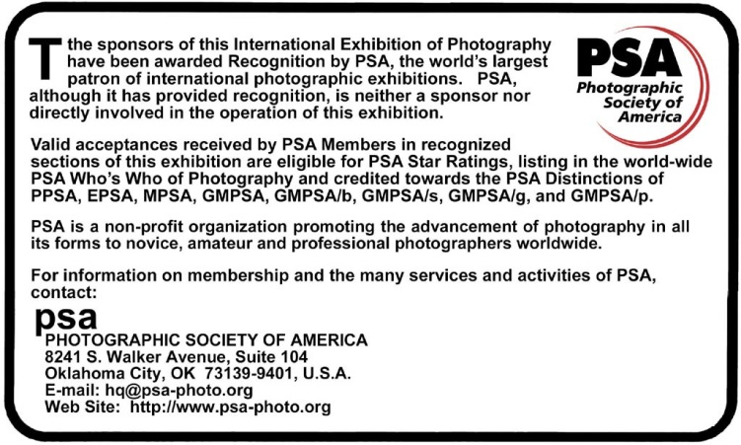

**Conditions of Entry**

This Exhibition will be conducted according to the practices recommended by PSA

|  |  |
| --- | --- |
| ***General Information***  **PSA Requirement:** Entries must originate as photographs (image-captures of objects via light sensitivity) made by the entrant on photographic emulsion or acquired digitally. By virtue of submitting an entry, the entrant certifies the work as his own and permits the sponsors to reproduce all or part of the entered material free of charge for publication and/or display in media related to the exhibition. This may include low resolution posting on a web site. The exhibition assumes no liability for any misuse of copyright. Images may be altered, either electronically or otherwise, by the maker and artwork or computer graphics created by the entrant may be incorporated if the photographic content predominates. The exhibition is open to anyone; however, an entry may be rejected when the sponsoring organization or its agent, in its reasonable discretion, believes the entry does not conform to exhibition rules and conditions.  **Number of Entries:** A maximum of four entries may be submitted for each section. Images (Slides or Digital) previously accepted at a Detroit International Stereo Exhibition*, or so similar as to be almost identical, regardless of title, are ineligible in any format. New work is required. An entrant's four images in a section will be distributed throughout four rounds of judging.  **Categories:** Attention is drawn to the awards allocated to various categories, and entries are especially sought for all of these.  **Entry Fee:** The Digital entry fee is US$6.00 worldwide. The Slide entry fee is US$8.00 US & Canada, $12.00 overseas. Cash or US$ check made payable to “DSS” may be sent for one or both sections. PayPal payments sent to [Dennis](mailto:Dennis)Green@Comcast.net may be made for one or both sections.  **Catalog:** A printed copy of the catalog will be mailed to each entrant and the list of acceptances, awards, etc. will be sent to PSA 3D Directors compiling “Who’s Who in Stereo Photography,” “Star Ratings” and “Image-of-the-Year” records.  **E-mailed Report Cards:** Report cardswill be sent via E-mail if an E-mail address is given on the entry form.  **Postal Mailed Report Cards:** If no E-mail address is given, report cards will be sent with the catalog.  **Modification:** Any modification of original images must be made by, or under the direction of, the exhibitor.   * *Also applies to any images accepted in the Exhibition under its previous titles, the Detroit International Stereo Slide Exhibition and the Detroit International Salon of Photography.* | |
| ***Stereo Slide Section Instructions***  **Slides** should be mounted in standard 1-5/8” x 4” (41 x 101mm) mounts only. Non-glassed RBT mounts are preferred; however slides in glass or cardboard mounts will be accepted. Maximum thickness of slides is 1/8”. Slide formats up to and including 8 perf will be accepted. However, due to limitations of the projection equipment, images wider than 30mm may lose some image width during judging. Careful attention to good mounting practice is requested including acceptable placement of the position of the stereo window. Please clean slides before packing.  2” x 2” (50 x 50mm) slides are not permitted.  **Loss or Damage:** All care will be exercised to guard against loss or damage to slides, but neither the Detroit Stereographic Society, nor any of its officers, can be held responsible in the event of loss or damage in transit or during judging and Exhibition sessions.  **Slide Markings:** Each slide must be labeled with the title of the slide and the maker’s name and address. The title must be affixed right side up on the front of the slide and a thumb spot affixed to the lower left hand corner as viewed in a hand viewer. Preferably, put name and address on back.  **Slide Credit:** Credit will be given in the catalog to the makers of all accepted slides. At the public showings, slides will be presented in the form of an audio-visual presentation and the names, cities, states and/or countries of residence of the makers of all accepted slides will be announced.  **Judging** will be by projection in a single session with all judges for each section present.  **Submission:** Mail your entries along with a completed entry form (below) to:  **Barb & Paul Gauche**  **46576 Vineyards Lane**  **Macomb, MI 48042 USA**  **Return:** Overseas entries will be returned by AIR. | ***Stereo Digital Image Section Instructions***  **Each stereo image** entry must consist of a single parallel view JPEG file. Maximum file size of each file should not exceed 1.5MB, total not to exceed 6MB.  Image width (horizontal) of each individual image should be 1400 pixels and the height (vertical) should be 1050 pixels, resulting in a combined file dimension of 2800 by 1050 pixels. We recommend the resize or multi-conversion features of StereoPhoto Maker for resizing from the original image dimensions to the required size.  **File Naming:** Please name the files containing your images as follows:  **Lastname_Firstname_Image Title_n.jpg**  Where n=1, 2, 3, and 4 in the order you wish them to be judged.  **(Example: Gauche_Paul_Sunset at the Lake_1.jpg)**  Please use underscores to separate the segments, and spaces (or hyphens where appropriate) between words in the image title, but no other special characters such as commas, brackets, periods, slashes, etc. If you have any questions regarding this format, please contact the Exhibition Chairman.  **Judging** will be by projection in a single session with all judges for each section present.  **Submission:** Attach all four entries to an E-mail and send to:  **Dennis**[**Green@Comcast.net**](mailto:Green@Comcast.net)  Please include “Detroit Exhibition Entries” in the subject line. We will try to acknowledge receipt of the E-mail within 48 hours.  If you have not received acknowledgement within 48 hours, please contact us again so we can ensure your images are included in the judging.  If you have a problem with E-mail reaching the above address, use the following alternate E-mail address: [bpgauche@msn.com](mailto:bpgauche@msn.com).  Copy the following and include the completed information in your E-mail:  Name___________________________________________________  Address_________________________________________________  City & State/Province_______________________________________  Zip/Postal Code_____________ Country________________________  PSA Star Rating___________ PSA Honors_____________________ |
|  | |

Please Complete Entry Form for Stereo Slides

and mail with your slide entries

**Please print or type** For Committee Use ______________

|  |  |  |  |  |  |  |  |  |  |  |  |
| --- | --- | --- | --- | --- | --- | --- | --- | --- | --- | --- | --- |
| Last Name | |  | | | First Name | | |  | | | |
| Address | |  | | | | | | | | | |
| City |  | | | | | | | | | | |
| State |  | | | Zip/Postal Code | | |  | | | Country |  |
| PSA Star Rating | | |  | | | PSA Honors | | |  | | |
| E-Mail Address | | |  | | | | | | | | |

**FEE:** The Slide entry fee is US$8.00 US & Canada, $12.00 overseas.

Please make checks (US funds) payable to “DSS”.

Entry fee may be sent via PayPal to [DennisGreen@Comcast.net](mailto:DennisGreen@Comcast.net)

|  |  |  |  |  |
| --- | --- | --- | --- | --- |
|  | **Stereo Slide Titles (Entrant to fill out)** | **Score** | **Acc.** | **Award** |
| 1 |  |  |  |  |
| 2 |  |  |  |  |
| 3 |  |  |  |  |
| 4 |  |  |  |  |

|  |
| --- |
|  |

|  |  |  |  |
| --- | --- | --- | --- |
| Address Label  For your use    Return labels will be computer generated from the entry form | **Stereo Slides from:**  **_________________________**  **_________________________ _________________________**  **_________________________** |  | **To:**  **Detroit International Stereo Exhibition**  Barb & Paul Gauche  46576 Vineyards Lane  Macomb, MI 48042  USA |
|  |